**ST.XAVIER’S COLLEGE**

MAITIGHAR, KATHMANDU



Computer Graphics

Assignment #7

Submitted By:

Anlisha Maharjan

013BSCCSIT006

2nd Year/ 4th Sem

Submitted to:

|  |  |
| --- | --- |
| Er. Anil K. Sah  Lecturer  Department of Computer Science |  |

Date of Submission: 1 September 2015

**SOURCE Code:**

//---------------------------------------------------------------------------

#include <vcl\vcl.h>

#pragma hdrstop

#include <math.h>

#include "trans.h"

//---------------------------------------------------------------------------

#pragma resource "*.dfm"

TForm1 *Form1;

int i,j,a,b,x,y;

int Tx,Ty;

int ang;

float Sx,Sy,m,n,o,p,q,r;

//---------------------------------------------------------------------------

__fastcall TForm1::TForm1(TComponent* Owner)

: TForm(Owner)

{

}

//---------------------------------------------------------------------------

void __fastcall TForm1::Button1Click(TObject *Sender)

{

Tx=StrToInt(Edit1->Text);

Ty=StrToInt(Edit2->Text);

x=Image1->Height;

y=Image1->Width;

for (i=0;i<=x;i++)

{

for (j=0;j<=y;j++)

{

a = i+Tx;

b = j+Ty;

Image2->Canvas->Pixels[a][b]=Image1->Canvas->Pixels[i][j];

}

}

}

//---------------------------------------------------------------------------

void __fastcall TForm1::Button2Click(TObject *Sender)

{

ang =StrToInt(Edit3->Text);

x = Image1->Height;

y = Image1->Width;

for(i=0;i<=x;i++)

{

for(j=0;j<=y;j++)

{

a = i*cos(ang)-j*sin(ang);

b = j*cos(ang)+i*sin(ang);

Image2->Canvas->Pixels[a][b] = Image1->Canvas->Pixels[i][j];

}

}

}

//---------------------------------------------------------------------------

void __fastcall TForm1::Button3Click(TObject *Sender)

{

Sx = StrToFloat(Edit4->Text);

Sy = StrToFloat(Edit5->Text);

m = Image1->Height;

n = Image1->Width;

for(q=0;q<=m;q++)

{

for(r=0;r<=n;r++)

{

o = q * Sx;

p = r * Sy;

Image2->Canvas->Pixels[o][p] = Image1->Canvas->Pixels[q][r];

}

}

}

//---------------------------------------------------------------------------

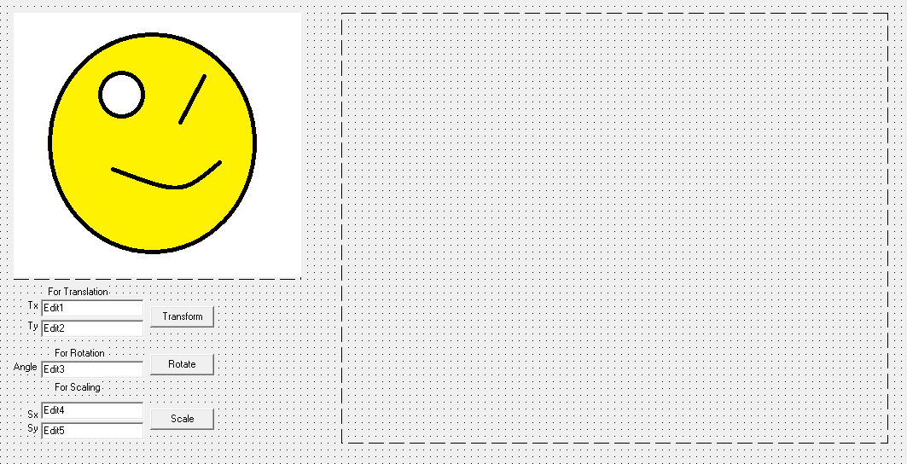

**OUTPUT:**

**Translation**

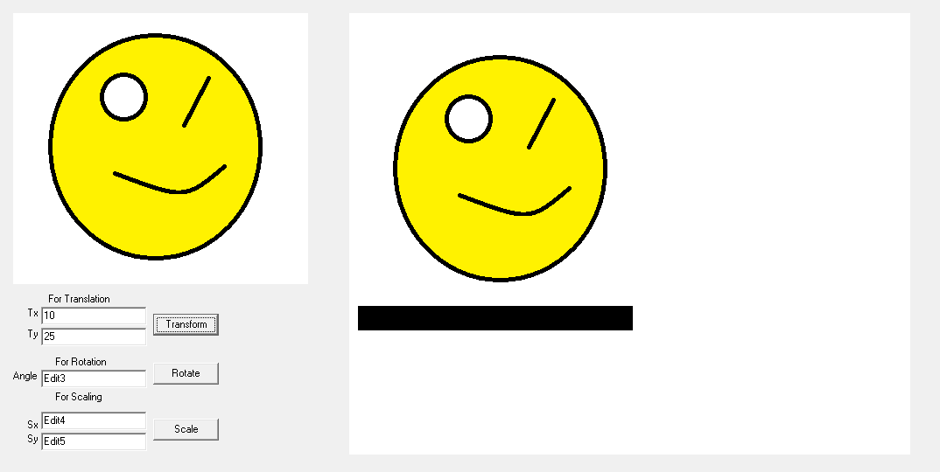

**Rotation**

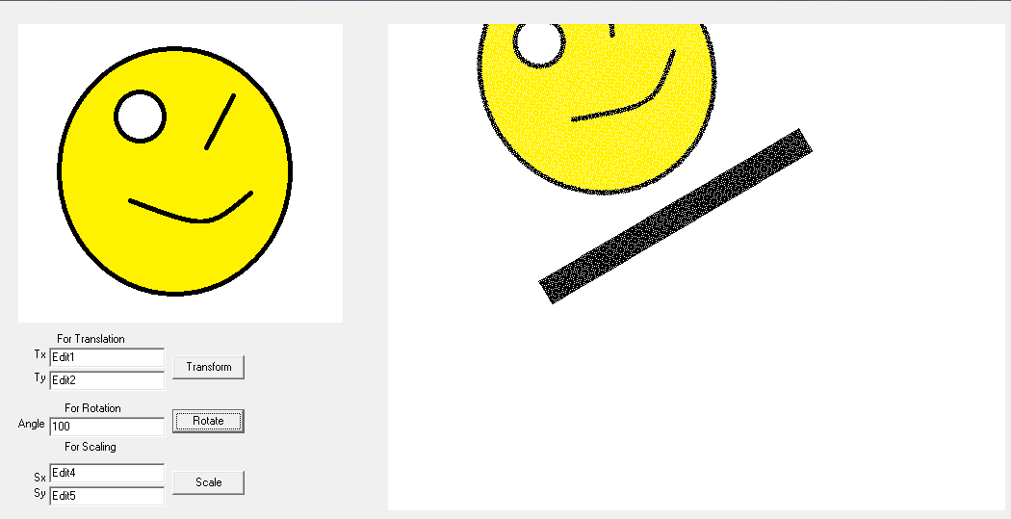

**Scaling**

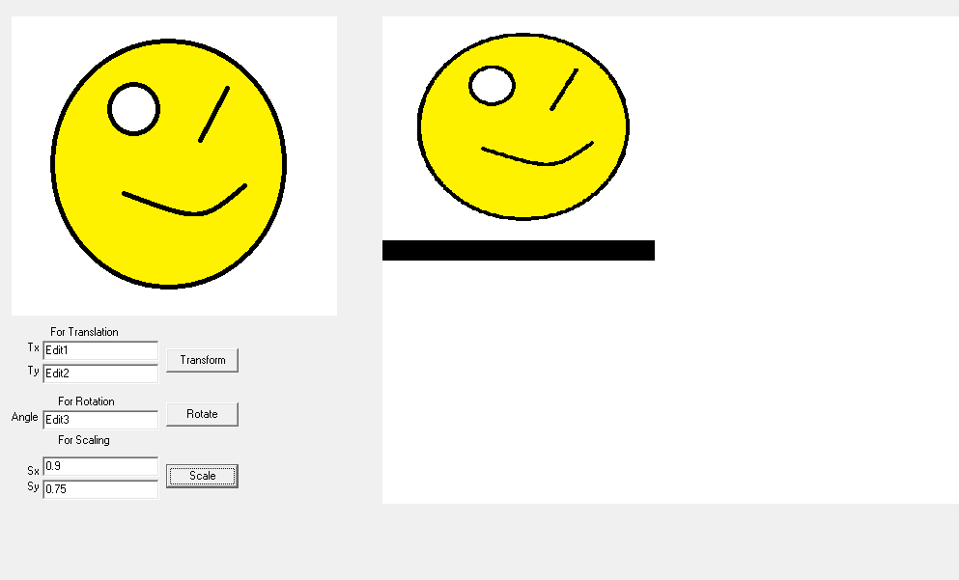

Conclusion: Thus in this way the image was translated, rotated and scaled using C++ builder.